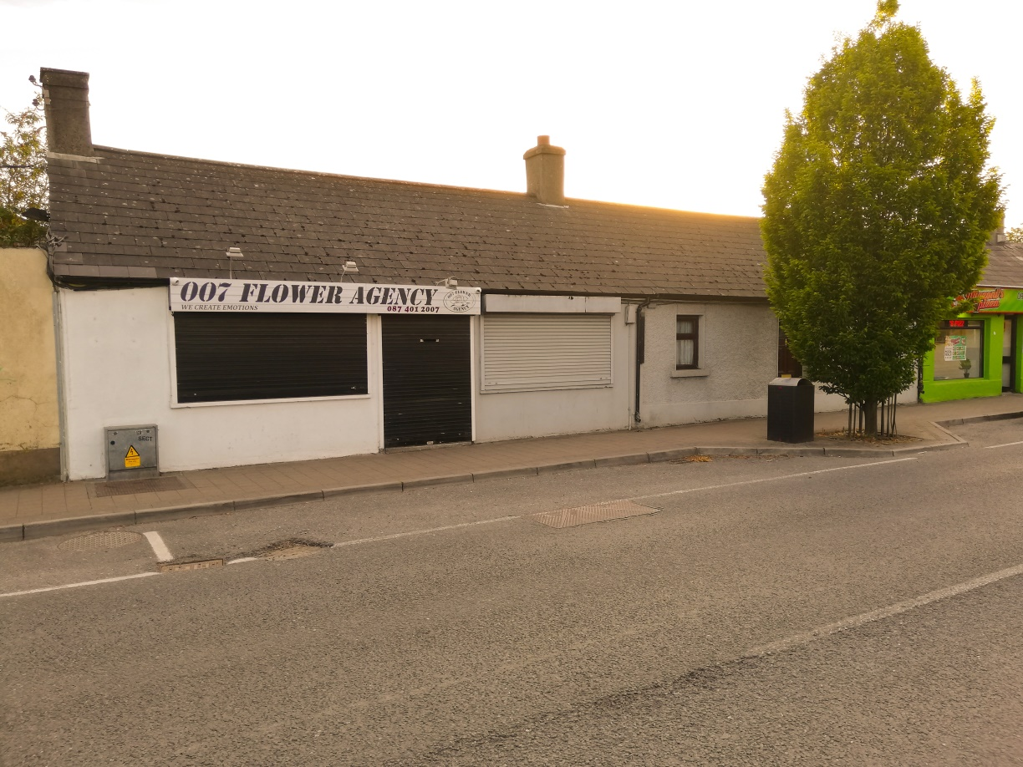

**F:\ADVERTISING & LOGOS FILE\LOGOS\Ber Certs\F_BER_RGB_Web_and_PC.png**

**10/11, Railway Street, Navan, Co. Meath.**

**C15 C6VA/C15 K7C5**

We offer to the market this excellent Residential & Investment Property opportunity. The residential unit is a 4 Bedroom Mid-Terrace, of c100sq m with rear backyard and access. The Commercial unit is currently trading as a flower Shop. These properties are located in the centre of Navan Town Centre with all its amenities.

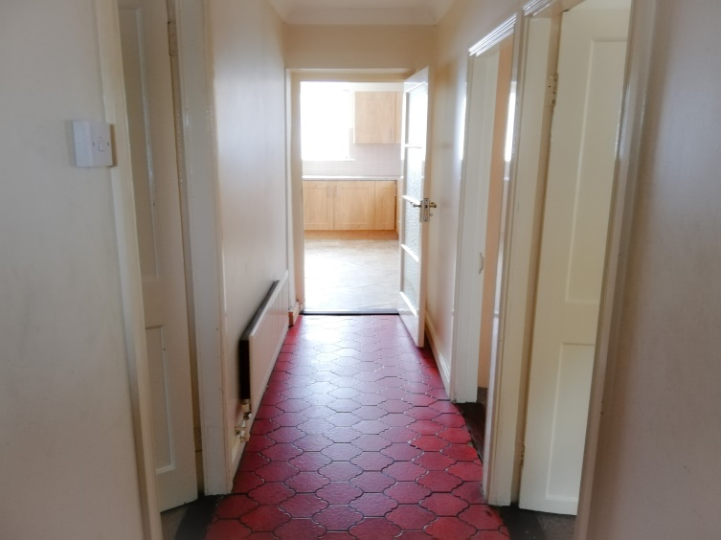

**Entrance Hall :**

1.1m x 4.5m

**Sitting Room :**

4.5m x 3.5m Carpeted and open fireplace

**Kitchen :**

4.4m x 3.9m Lino Flooring, Electric Cooker and Hood. Fridge Freezer and Utility.

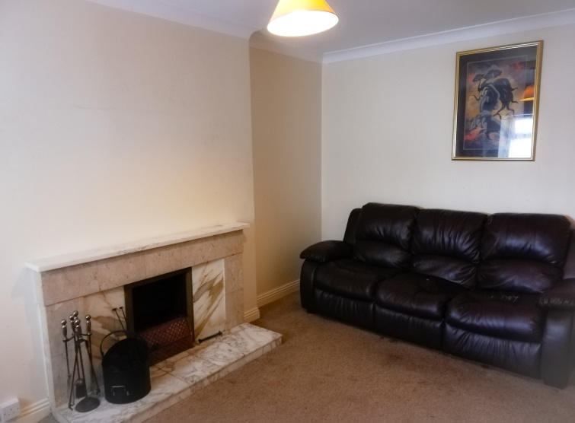

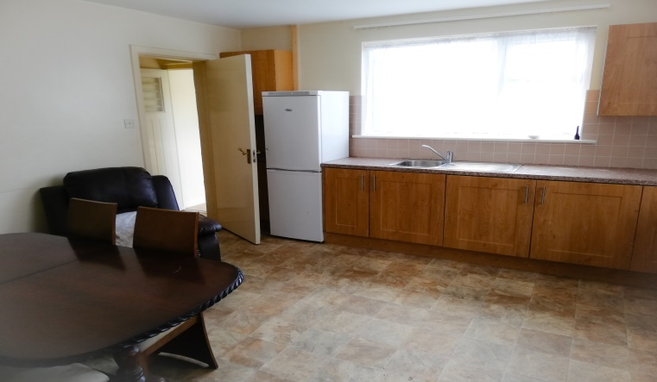

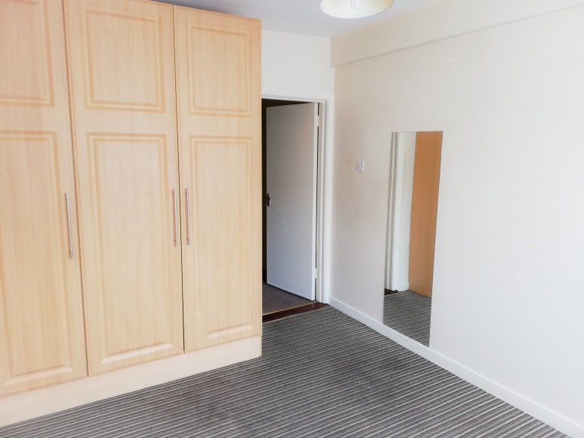

**Bedroom 1 :**

4.1m x 2.8m – Floor Carpeted and Built in Wardrobe

**Bedroom 2 :**

4.0m x 2.9m – Carpeted Floor and Built in Wardrobe

**Bedroom 3 :**

3.2m x 2.4m

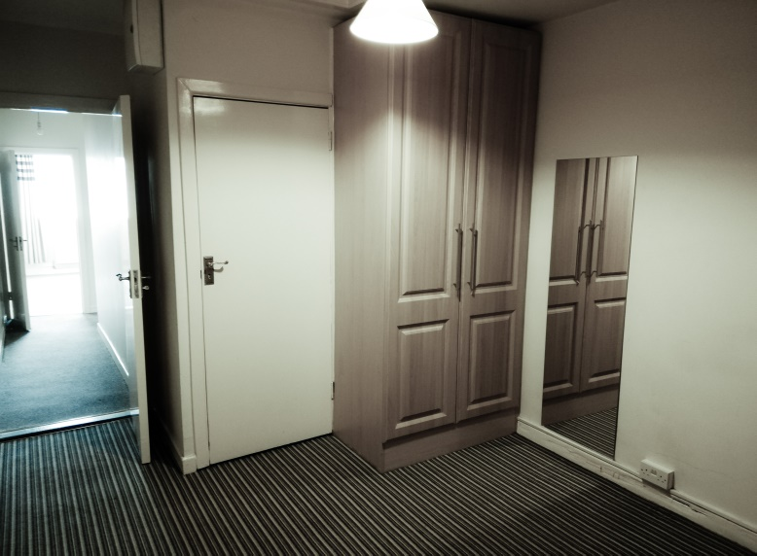

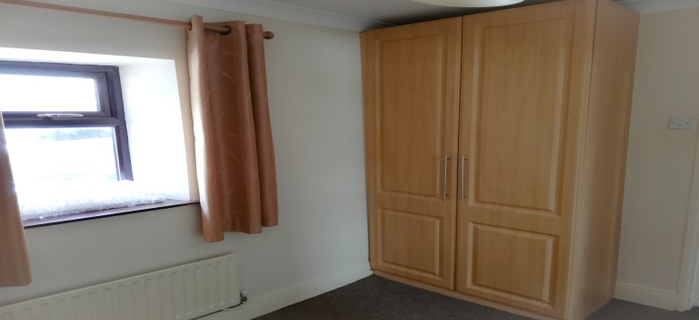

**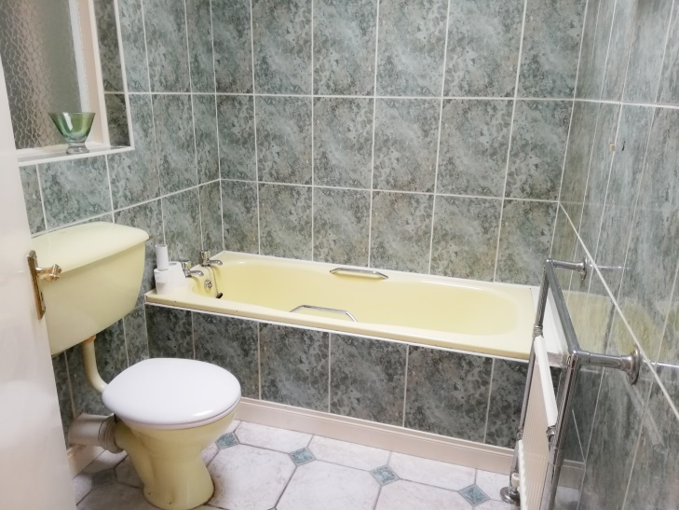**

**Bathroom :**

2.3m x 1.8

**Back Garden**

**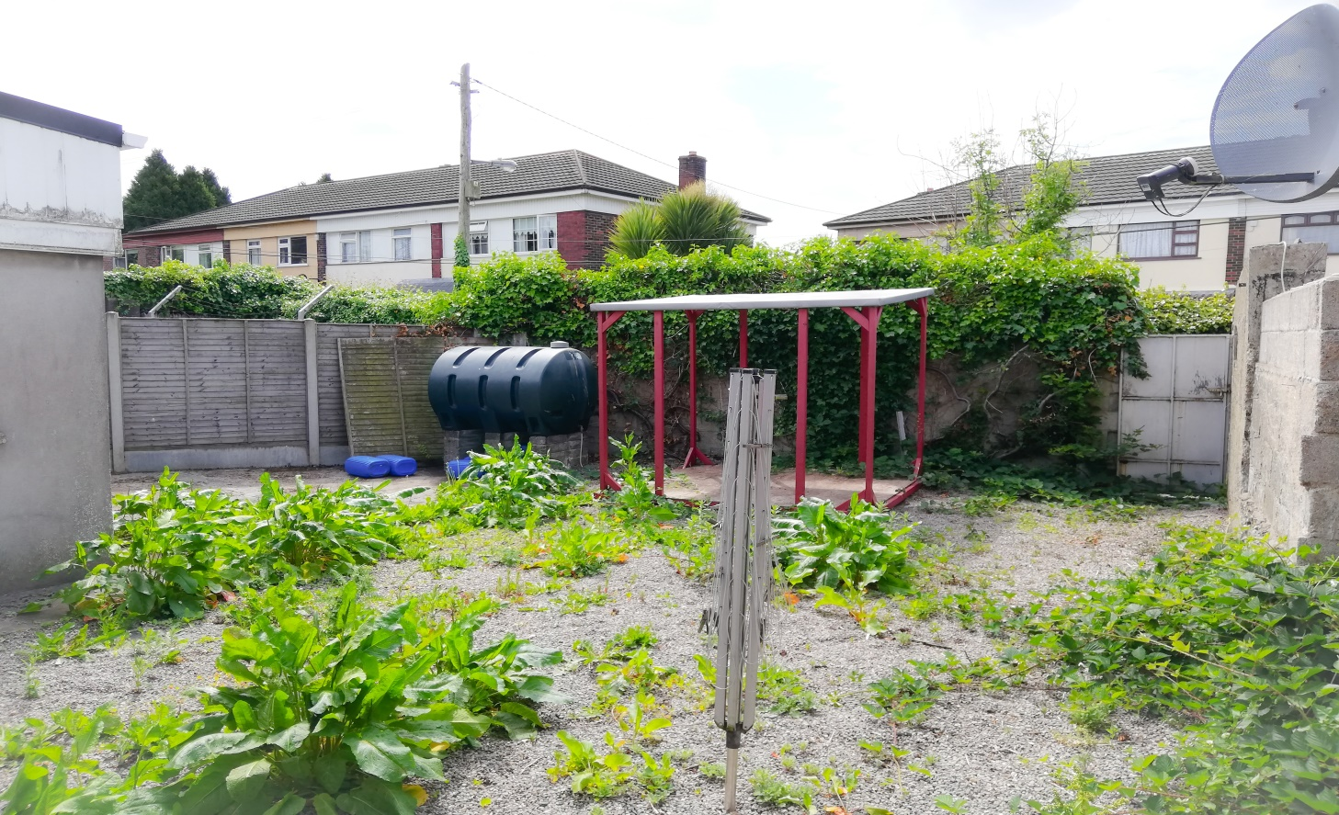**

**Features :**

Features the combined unitis total c.163sqm and are situated on c.0.1 acres Zoned B1 Development potential. Oil fired central heating mains water, mains sewage, rear yard with vehicular access. Minutes walk from Navan Town Centre and all town amenities.

**Eircode :**

**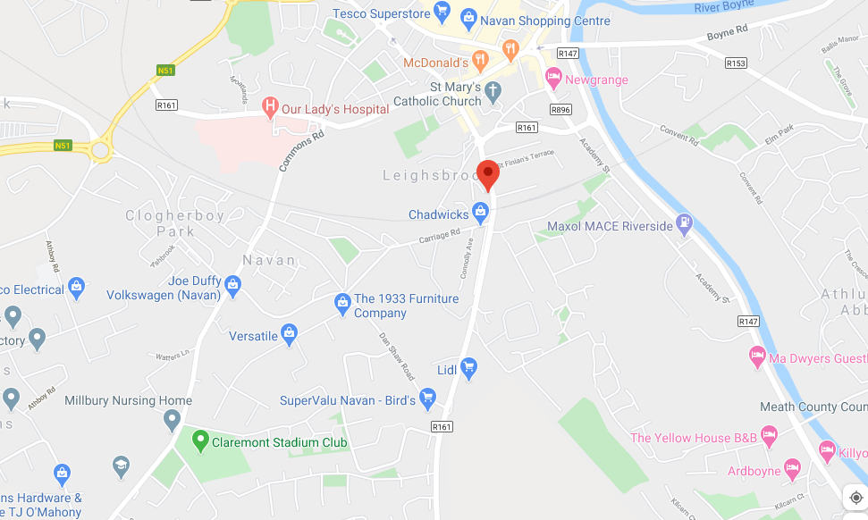**

**Price : €245,000**

Oliver Farrell QFA

Michael Cassidy Financial Broker

**PENSIONS**

**LIFE COVER**

**MORTGAGES**

**01-8259622**

**www.foleyauctioneers.ie**

**

